Willenhall Primary Care Centre – 1
June 2024

diabetes week 2024
Diabetes Week is a week to make some noise, raise awareness and shout about the things that matter to people with diabetes, shining a light on what it’s like to live with day in, day out.
This year, we want to talk about the health checks you need when you have diabetes.
We know life with diabetes can feel like number, check and test overload. You might feel fine, or feel like you don’t have the time. Or maybe you’re not sure what checks you should be getting. But these regular diabetes health checks are vital to keep you healthy, so you can continue living life to the full.
Find out how you can get involved below, and if you have any questions, get in touch by emailing diabetesweek@diabetes.org.uk
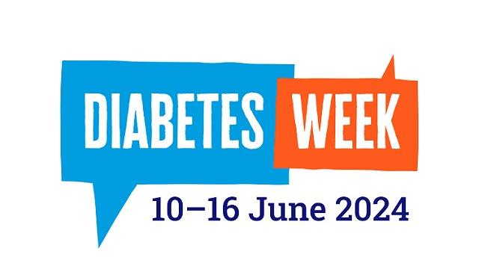

Practice Closure notice.

The practice will be closed on Wednesday 26th June 2024 at 1pm – 6.30pm for staff training.

What is Carers Week? 10-16th June 2024
Carers Week is an annual campaign to raise awareness of caring, highlight the challenges unpaid carers face and recognise the contribution they make to families and communities throughout the UK. It also helps people who don't think of themselves as having caring responsibilities to identify as carers and access much-needed support.
The campaign is brought to life by thousands of individuals and organisations who come together to provide support for carers, run activities, highlight the vital role carers play in our communities and draw attention to just how important caring is.
This year the theme is 'Putting Carers on the Map' highlighting the invaluable contributions of carers across the UK and ensuring their voices are heard loud and clear. Together we want to help increase the visibility of the carers among politicians, employers and throughout our communities. And by raising awareness we hope they will better recognise the challenges unpaid carers face and help them access the support they deserve.

Armed Forces Day 2024
Armed Forces Day takes place on the last Saturday each June, falling this year on 29 June.
It is a chance to show your support for the men and women who make up the Armed Forces community: from currently serving personnel to Service families, veterans and cadets.
It also marks the culmination of a week of celebrations, beginning on Monday 24 June, when the public show their support and appreciation for the Armed Forces community. It also includes Reserves Day (26 June), which provides the country with an opportunity to recognise our Reserve Forces.
There are many ways for people, communities and organisations across the country to show their support and get involved. Use our interactive map to find your local event.

