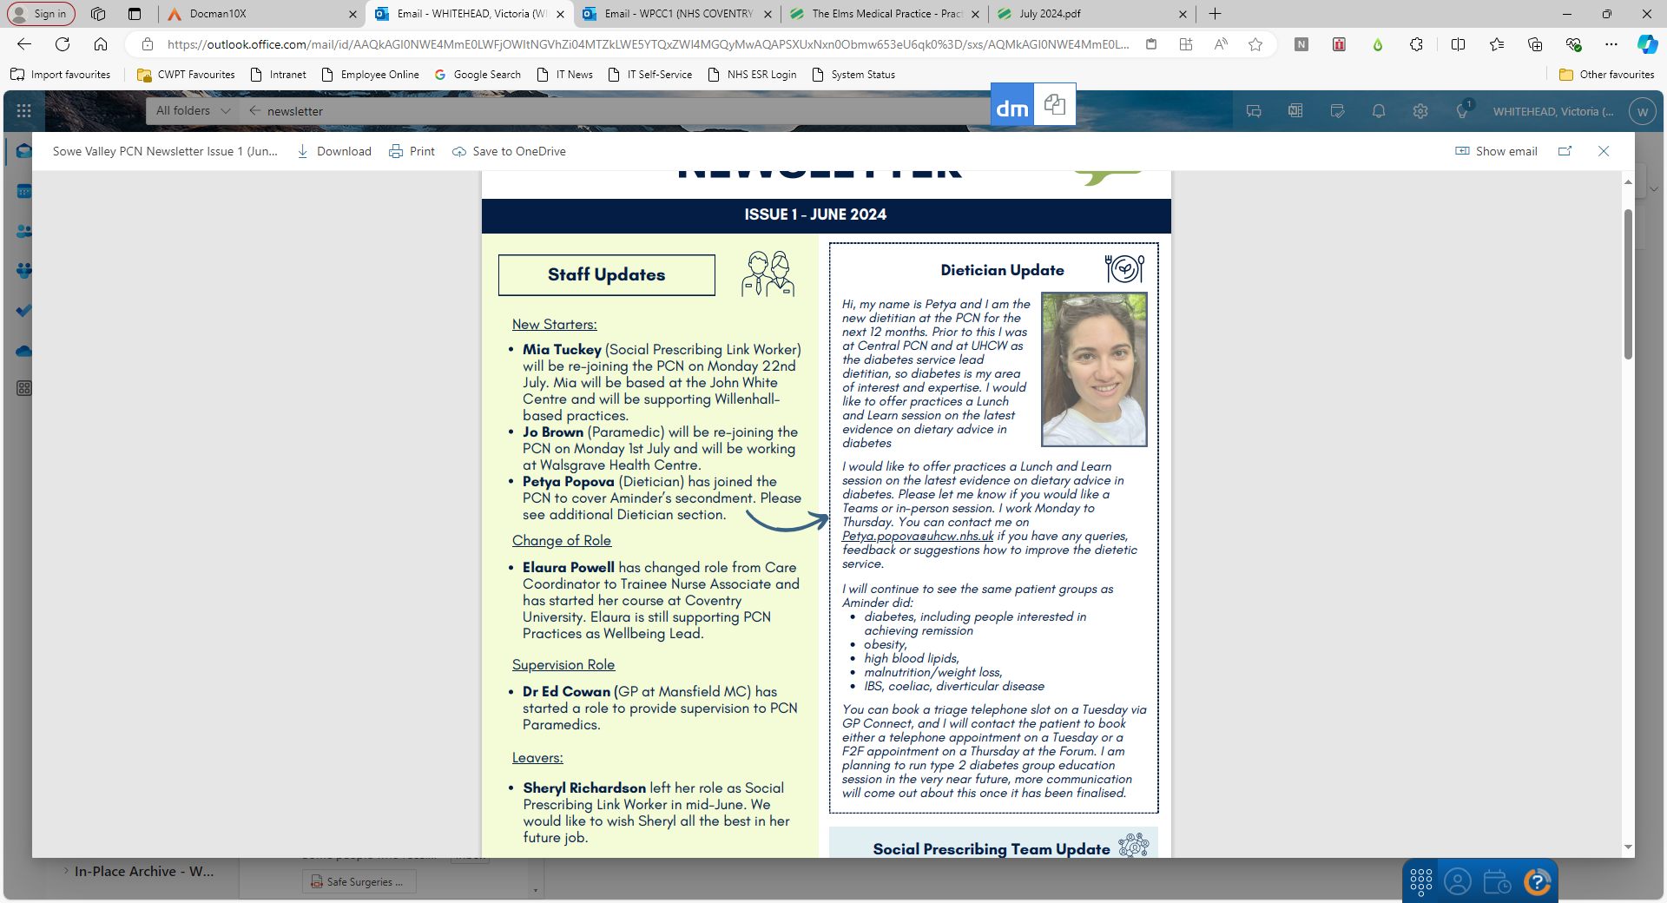

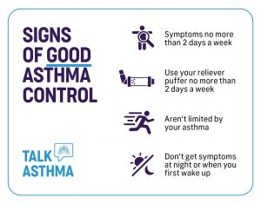





**Willenhall Primary Care Centre – 1**

**July 2024**

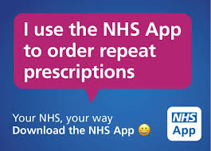

TELL US HOW WE’RE DOING! The team at Willenhall Primary Care Centre-1work very hard to provide a high quality and responsive service to our patients but we are always looking for ways to improve our service and listen to what patients have to say. There are lots of ways for patients to have their say and we would appreciate hearing from you with any comments you may have as to how we can improve our service to you. **tel:02476302082**

**cwicb.wpcc1coventry@nhs.net** We will also send you a family and friend text message with a link for you to provide your feedback.

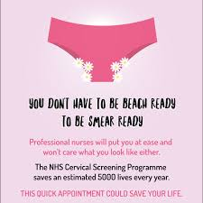

**Whooping Cough**

Cases of whooping cough are continuing to rise. If you are pregnant, it's important to get the whooping cough vaccine to protect your newborn baby, as they are at greatest risk. Find out more. [https://www.nhs.uk/conditions/who oping-cough/](https://www.nhs.uk/conditions/who%20oping-cough/)



**PRESCRIBED MEDICATION & WASTAGE**

Each year across the NHS, approximately £300 million is lost due to medicine wastage, at least half of which is avoidable. This is a result of medication overordering and over use. To help reduce costs of medicines, please only order medications you need. If you feel you no longer need a medication or are not currently taking a medicine as prescribed, please book to speak to one of our pharmacy team at the practice. Taking medications you have been prescribed correctly is important for your safety. Many conditions need careful management and monitoring to ensure they are well treated. Skipping doses, taking too much medication or not following the prescribed schedule can have negative consequences. The cost to the NHS of people not taking their medicines properly and not getting the full benefits to their health is estimated at more than £500 million a year. If you have any queries or concerns about your prescribed medications, please book to speak to a Clinical Pharmacist



**CHECKING INTO RECEPTION**

Where possible, please use the check-in screen to mark yourself in for CHECKING INTO RECEPTION

Where possible, please use the check-in screen to mark yourself in for your booked appointment. The check in screen is located at the back of main reception.

This helps us to reduce queues at the front desk and means we can support patients with queries quickly and get appointments booked. with queries more quickly